Prehistory of Empire-like Behavior:

- Monroe Doctrine
- US projection across the Pacific
- Us achievement of the A-Bomb
- Creation of the US Deep State
- Creation of the EU
- The Exchange Stabilization Fund and its predecessors

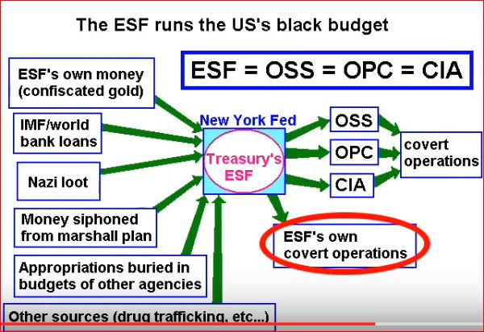

The American unipolar moment began in earnest following
the fall of the Berlin Wall and the dissolution of the Soviet Union,
thereby offering the American elite the crazy idea of seeking to achieve total global hegemony
by conquering the nations of the Heartland, especially through economic and military means.

